Analog Communications Lab
Laboratory Manual



Prepared by
DR EMMANUEL AMPOMA AFFUM

DEPT. OF TELECOMMUNICATION ENGINEERING-KNUST

JANUARY 2024
DEPARTMENT OF TELECOMMUNICATION

TE 271: ANALOGUE COMMUNICATION LAB

List of Experiments

Characteristics of a Mixer.

- Amplitude Modulation and Demodulation.

Modulation characteristics of AM transmitters.

- DSB-SC Modulation and Demodulation.

Characteristics of Phase Locked Loop (PLL).

- Frequency Modulation and Demodulation using PLL.

Pre-emphasis and De-emphasis.

- Pulse Amplitude Modulation and Demodulation.

Pulse Width Modulation and Demodulation.

- Pulse Position Modulation and Demodulation.

General Guidelines

The main goal of the TE 271 laboratory is to provide you, the student, with the basic laboratory skills that are needed in the design, analysis and implementation, of devices and sub-systems of modern communication systems. It is assumed that you have basic knowledge and command of laboratory skills learnt previously in our ECE laboratories. These skills shall include the use of an oscilloscope to perform measurements of circuit responses in the time domain, a function generator, a multimeter and a dual-output power supply. It is also assumed that you possess basic circuit building skills using a breadboard to wire and debug circuits given a circuit diagram.
In most of the experiments of this laboratory, you will be using circuits operating with signals of frequency components of up to 20 MHz. For this reason, it is very important that your circuit be assembled in a breadboard neatly, using the shortest possible connecting wires. In some cases, the circuits may produce unexpected signals. In determining the causes of this behavior, you should suspect first improper wiring of components and integrated circuits. It is therefore essential that you build the circuit in advance before going to the lab session.
Please feel free to ask the instructor for assistance should you have any questions about an experiment. TE 271 lab is unique in that its content is closely tied to the class room lectures. You must ensure to understand the concepts and problems associated with each class topic in order to ensure success in the lab. One week after completion of each experiment a report is due. Details on the preparation of an experiment and its report are given in the next section.

Preparing for the experiment:
In general, every experiment of the TE 271 laboratory requires two hour period and there is one lab session per week. Prior to performing the experiments, it is extremely important that you prepare in advance all the required circuitry and read carefully the experimental procedure. Failure to do this will result in most of the time in the lab being spent on assembling the circuit rather that testing it and taking measurements. Remember to use connecting wires of the smallest length to avoid spurious responses. This will lead to a successful completion of all activities in each experiment. In every experiment you are required to perform analytical and computational work in advance. This is to be included in a lab notebook, which you are

required to keep and that will be revised periodically by the instructor to ensure that this “pre-lab work” is performed. Specifically, the following activities shall to be performed before each experiment:
  - Read completely the description of the experiment.
  - Understand the circuit diagrams and all materials to be used. These include
equipment user’s manuals and data sheets, which are available in the labs.
  - Complete all computations, plots and tables, as required in the “pre-lab work” section of the procedure of an experiment. All the times, the instructor may direct you to Multisim / Matlab / Simulink / Lab View models to produce theoretical results that can be used in comparisons with experimental data.
The activities above allow the time in the lab to be spent on the instructor’s presentation and on taking laboratory measurements. You must administer wisely your time in the lab to ensure that the experiment is finished successfully.
Minimum of ten experiments are required to perform by the students in this lab course. Out of these five experiments are to be done in the normal lab session and remaining experiments are performed in open-lab session.

Organization of experimental procedures
Every experiment is described in a procedure that contains the following sections:

Introduction
  - Objectives
  - Required reading
  - List of equipment and components

Theory
A small section devoted to the fundamental ideas and theory behind the experiment. It may contain equations that are needed for pre-lab work and the report. This section is not intended to replace the material presented in the lecture but rather to serve as a reference point.

Instruments and Material
Describes a summary of the operation and use of those components or integrated circuits that may be unfamiliar to students.

Pre-Lab Work
Description of any analysis, derivations and computations required prior to the experiment. This may include simulations of computer models (usually in Multisim /

Matlab / Lab View). Understanding the data sheets of the components used in the experiments.

Measurements
A guideline to measurements required in the experiment. The student is invited to modify and/or take any additional measurements that may help in obtaining further insight to the basic principles addressed by the experiment.

Analysis of Results
Further computations, derivations, tables and plots, to be carried out after the experiment in order to present the measurements and highlight fundamental concepts. This may include running computer simulations to generate data to be compared with those obtained in the laboratory. Questions and issues pertinent to the results and preparation of the lab report will be posed in this section.

Laboratory reports
Every experiment of the TE 271 laboratory requires a report that shall be structured as follows:

Cover page
- Number and title of the experiment
- Lab section number
- Lab workbench number
- Student names, Roll No. and ID. No
- Date

Introduction:
Provide in this section a brief (one or two paragraphs) description of the topic(s) and basic principle(s) that the report covers.

Changes or additional procedures (optional)
Describe here any procedure changes beyond those described in the experimental procedure. Any additional procedures and measurements taken during the experiment shall be mentioned in this section.

Pre-lab work
Give a description of any computations needed prior to the experiment. If carried out by hand, write the equation used and provide a numerical example. In the case of computer programs and/or simulation models, you must include the listing of the program and/or a block diagram of the model with a detailed description of each

block. Results shall be presented in the form of tables and/or graphs and produced neatly. Do not copy verbatim the text included in the experimental procedure.

Experimental measurements
The measurements shall be presented in the report in this section in the form of tables and/or graphs. You must ensure that the tables and graphs are clearly labeled with captions that describe the data presented.

Analysis of results
This section contains further analysis of the data obtained in lab measurements and its relationship with theory. Computations carried out by hand, require you to write the equation(s) used and provide a numerical example(s). In the case of computer programs and/or simulation models, you must include the listing of the program and/or a block diagram of the model with a detailed description of each block. Use neatly produced and clearly labeled tables and/or graphs to support your analysis. In particular, the text included in this section shall refer to table/graph labels.

Discussion
Generally, the discussion of the results will include answers to any questions posed in the experimental procedure. The particular importance here is the comparison between theoretical predictions based on equations or computer models and your measurements. Note finally that a formal error analysis is not required in this laboratory.

Conclusions
Your conclusions shall be brief and to the point. Two or three paragraphs are usually sufficient. References to figures and graphs from previous sections of the report and the experimental procedure are not only desired but highly encouraged. Add here any comments that you or your team may have on future improvement to the experimental procedure and circuitry.

In general, lab reports are graded based on the data gathered in the experiments, their proper presentation, analysis and the correlation between experimental, theoretical and computer-based results.

Characteristics of a Mixer

Objectives:
- To construct and study the characteristics of a Mixer.
- To Predict the frequencies generated in a non-linear mixer.
- To examine the time displays of a Mixer.
.

Pre-Lab Work:
- Basic theory of Mixer.
- Time and Frequency analysis of DSB-SC Mixer.
- Understanding the circuit diagrams of Mixer.
- Understanding the data sheets of components used in the experiment.
- Computer simulations (Multisim / pSpice) are performed and the objectives are obtained prior to the hardware experiment.

Equipment and Components:

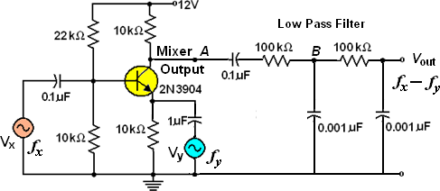
Circuit Diagram:
Fig 1. Circuit diagram of Mixer.

Basic Theory: An electronic mixer is a device that combines two or more electrical or electronic signals into one or more composite output signals.as shown in Fig.2. Multiplying mixers multiply together two time-varying input signals instantaneously (instant-by-instant). If the two input signals are both sinusoids of specified frequencies
f x and f y , then the output of the mixer will contain two new sinsoids that have the sum

fx + f y frequency and the difference frequency absolute value | fx - f y |. In Fig.2, the

input signals have frequencies of
f x and
f y . Because of non-linear distortion, the

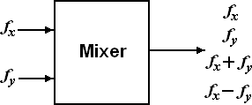
output signal contains the original input frequencies, sum and difference frequencies plus their harmonics. For instance, if the two input frequencies are 100 and 101 kHz, the output signal contains the frequencies, 100, 101, 200, 202, 300, 303 kHz, and so on.
Fig.2. A mixer produces the original frequencies, the sum, and the difference

In addition to the harmonics that are produced, new frequencies appear in the output

that are equal to the sum and difference of the two input frequencies. If

the input frequencies, the new frequencies are
f x and
f y are

Sum =
fx + f y

Difference frequency absolute value = | fx − f y |
Fig.1 is an example of a transistor mixer. One signal drives the base; the other drives the emitter. One of the input signals is large; this is necessary to ensure non-linear operation. The other input signal is usually small. One of the reasons this small is because it often is a weak signal coming from an antenna. At the output of collector, the two original frequencies, sum, difference and their harmonic frequencies are produced. The mixer output of Fig.1 is filtered by two low-pass RC circuits (2nd order LPF) that eliminates all the higher frequencies and passes only the difference frequency signal.

The approximate cutoff frequency of each RC circuit is given by

Procedure:
fc =
1

2π RC .

- Connections are made as per the circuit diagram shown in Fig.1.

- Turn Vy
down to 0. With the oscilloscope, adjust Vx
to 0.1 Vpp . Set the

frequency 101 kHz.

- Now adjust Vy
to 1 Vpp
and 100 kHz.

- Observe the final output signal with a vertical sensitivity of 0.1 V/cm (ac input)

and a sweep time of 0.2 ms/cm. Vary the frequency of the Vx
generator slowly in

the vicinity of 101 kHz until you get a 1 kHz output signal. Tabulate the results.
- Observe at point B, the input to the final RC filter. Note the ripple on the 1kHz signal.

- Observe at point A, the input to the first RC filter. Use vertical sensitivity of 2V/cm. Note how large the ripple is here.
- Repeat the above steps for various in put frequencies.

Observations:
S. No | f x | f y | | fx − f y |
1
2
3
4

Precautions:
- Connections should be made carefully.
- The resistors and capacitors must be identified properly before giving the circuit connections.
- The components must be properly doped into the bread board.

Results:

Post-Lab Requirements

- Create the illustration for Mixer.
- Compare the results are obtained in hardware lab with that of computer simulations.
- Submit your illustration to the lab instructor at next week's lab.

Viva Questions:
- Why do you not see the original frequencies?
- To observe 2( fx − f y ) what modifications to be done in the filtering circuit ?
- Why do you not see the sum and higher harmonic frequencies?

- If the frequencies of Vx
(100 kHz) and
Vy (101 kHz) are interchanged, what is

the out put frequency ?

2. Amplitude Modulation & Demodulation

Objectives:
- To construct and study the Amplitude Modulation technique.
- To examine the time displays of an AM signal.
- To measure the percentage modulation, and the percentage of total power in both sidebands and in the carrier versus the modulation index.
- To investigate the use (& limitation) of envelope detection in demodulating AM signals.

Pre-Lab Work:
- Basic theory of Amplitude modulation and envelope detection techniques. Time and Frequency analysis of AM waves.
- Understanding the circuit diagrams of AM generation and envelope detection.
- Understanding the data sheets of components used in the experiment.
- Computer simulations (Multisim / pSpice) are performed and the objectives are obtained prior to the hardware experiment.

Equipment and Components:

  - Bread board trainer.
  - Regulated Power Supply (0-30v)
  - C.R.O
  - Function generator
  - Decade inductance box
  - Resistors 100kΩ 22kΩ, 10kΩ- 4 Nos, 1kΩ-3 Nos, 3.3kΩ, 22kΩ potentometer
7. Capacitors 0.001μF-2 Nos, 1μF, 10μF, 0.1μF-4 Nos.
- Transistor 2N 3904.
- Diode OA-79 / 81

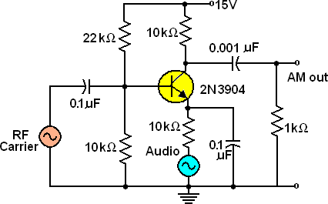
Circuit Diagram:
Fig 1. Circuit diagram of Amplitude Modulation

Brief Theory:

AM Modulation:
Amplitude Modulation is defined as a system of modulation in which the amplitude of

the carrier wave
c(t) = Ac cosωct
is varied linearly with the instantaneous amplitude of

the message signal
m(t) . The terms
Ac is the amplitude and ωc
is the frequency of the

carrier wave respectively. The standard form of amplitude modulated (AM) wave is defined by

s(t) = Ac[1+ kam(t)]cos 2π f_{c}t
(1)

where
Ka = 1/ Ac
is a constant is called amplitude sensitivity of the modulator. The term

Ac[1+ Kam(t)] is referred to as envelope of the AM wave.

Consider a modulating wave
m(t)
that consists of a single tone or frequency

component. That is
m(t) = Am cos 2π f_{m}t , where
Am is the amplitude and
f_{m} is the

frequency of the modulating wave respectively. Then the AM wave is described by

s(t) = Ac[1+ μ cos 2π fmt]cos 2π fct
(2)

where
μ = ka Am = Am / Ac
is called modulation factor or percentage modulation. To

avoid envelop distortion due to over modulation, μ must be kept below unity.

Let
Amax
and
Amin
denote the maximum and minimum values of the envelop of the

modulated wave,

Then
Amax Amin
= Ac (1+ μ)
Ac (1− μ)
⇒ μ = Amax − Amin
Amax + Amin

(3)

With this notation we can write the AM wave s(t) as
s(t) = Ac cos 2π f_{c}t + μ Ac cos 2π f_{m}t cos 2π f_{c}t

= A cos 2π f t + μ Ac cos(ω − ω )t + μ Ac cos(ω + ω )t
(4)

c c 2 c m 2 c m
Fig.1 shows the circuit diagram of Amplitude Modulation, and Fig.2 illustrate the AM modulated wave for various modulation indices.

The total power in the AM modulated wave is given by
Pt = Pc + PLSB + PUSB , where

P = Pc ⎛1+
t ⎜
μ 2 ⎞
⎟ ,
2
Pc = c ,
A
2 2
c
P μ A= P P =
LSB USB c

are the total power, carrier power,

⎝ 2 ⎠ 2 8
lower and upper sideband powers respectively.

The transmission bandwidth of the AM wave is exactly equal to the twice of the message

bandwidth. Transmission bandwidth = USB - LSB = ( f +W ) −( f −W ) = 2 W
Hz, where

‘W’’ is message signal bandwidth. In the case if single tone signal
m(t) = Am cos 2π f_{m}t the bandwidth is 2 f_{m} Hz.

AM Demodulation:
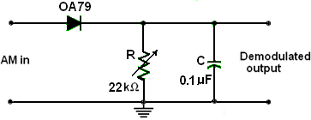
The process of extracting a base band signal from the modulated signal is known as de- modulation. AM signal with large carrier are detected by using the envelope detector. The envelope detector employs the circuit that extract the envelop of the AM wave. The envelope of the AM wave is the base band signal. However, a low level modulated signal can be detected by using square law detector in which a device operating in the non linear region is used to detect the base band signal. A diode operating in a linear region of its characteristics can extract the envelop detector. it is very simple and less expensive AM demodulation technique. Fig.3 illustrate the circuit diagram of envelope detector.
Fig 2. Circuit diagram of Envelope Detection.

Procedure:
AM Modulation:
- Connections are made as per the circuit diagram shown in Fig.1.
- Set audio signal generator (modulating signal) to 200 Hz and RF carrier signal generator to 500 KHz.
- Turn the audio generator down to 0 (do not disconnect). Adjust the RF signal generator to get a final output (at AM out) of 0.3 V p-p. (See that no distortion occurs).
- Use sweep speed of 1 ms / cm. Turn up the audio signal and observe the Amplitude Modulated signal.
- Find the modulating index by noting maximum and minimum amplitudes from the modulated signal.
- Now Increase and decrease the modulating signal and note how the percentage modulation changes. Calculate the corresponding modulation indices and tabulate them.

- Repeat the step 7 by varying the frequency of modulating signal.
- Plot the graphs: Modulation index vs Amplitude & Frequency.

AM Demodulation:
- Connect the demodulation circuit as shown in Fig.2.
- Now the demodulation circuit is connected across the output of modulator circuit.

- Design the value of R (and C) by using the equation 1
fc
reproduction of demodulated signal. (Typically R = 10 K)
<< RC <<
1 for proper
fm

- Observe the demodulated signal and measure amplitude and frequency of demodulated signal.
- By varying the ‘ R ‘ observe the demodulated signal.
- By varying the modulating voltage in the AM modulation circuit, observe the demodulated signal.
- Similarly, by varying the modulating signal frequency in modulation circuit, observe the demodulated signal.

Observations:

Ac | Am | Amax | Amin | Modulation  Index | %modulation

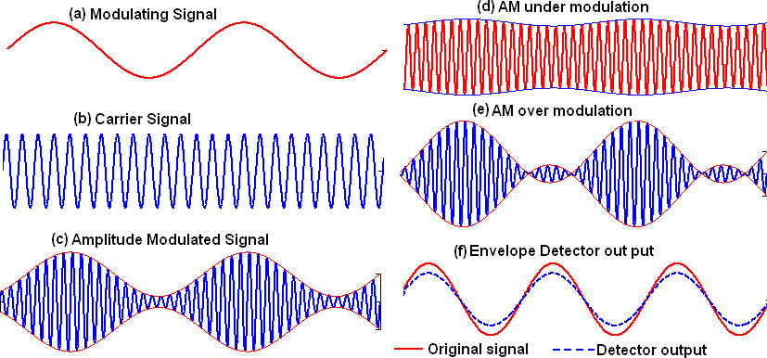
Model Wave Forms:
Fig 3. Amplitude Modulation waveforms with various modulation indices and Envelope detector output waveforms

Precautions:
- Check the connections before switching ON the power supply
- Observations should be done carefully.

Results:

Post-Lab Requirements

- Create the illustration for Amplitude Modulation.
- Compare the results are obtained in hardware lab with that of computer simulations.
- Submit your illustration to the lab instructor at next week's lab.

Viva Questions:
- Why modulation is necessary?
- Define AM and draw its spectrum? What is its band width?
- Why percentage modulation is always less than 100 % in case of A.M.?
- Give the significance of modulation index?
- What are the different degrees of modulation?
- What will be the change in modulation index if there is change in amplitude of modulating signal ?
- What will be the change in modulation index if there is change in frequency of modulating signal ?
- Compare linear and nonlinear modulators?
- Explain how AM wave is detected?
- What are the different types of distortions that occur in an envelop detector? How can they be eliminated?
- How many channels are contained in the AM broadcast band?
- What is the bandwidth of each of the channels in the AM broadcast band?
- Draw AM signal in which carrier signal is sinusoidal and modulating signal is triangular wave.
- An audio signal of 7.5 KHz with a peak of 4.5 Volts modulates the carrier of 7.5 Volts peak with frequency 510 KHz. Find out the modulation index.
- What is the bandwidth requirement for the AM signal when the frequencies of the modulating signals 200 Hz, 400 Hz and 800 Hz are transmitted simultaneously?

3. Modulation Characteristics of AM Transmitters

Objectives:
  - To construct and study the modulation characteristics of AM transmitters.
  - To study the non-symmetry of AM waves.
  - To examine the time displays of trapezoidal patterns.
.

Pre-Lab Work:
- Basic theory of characteristics of AM transmitters (trapezoidal patterns).
- Basic theory of Amplitude Modulation..
- Understanding the circuit diagrams of Mixer.
- Understanding the data sheets of components used in the experiment.
- Computer simulations (Multisim / pSpice) are performed and the objectives are obtained prior to the hardware experiment.

Equipment and Components:

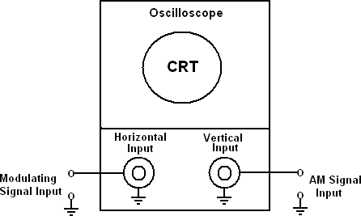
Experimental Set up:
Fig 1. Test set up for displaying a trapezoidal pattern on an Oscilloscope.

Basic Theory: Trapezoidal patterns are used for observing the modulation characteristics of AM transmitters (i.e., coefficient of modulation and modulation symmetry). Although the modulation characteristics can be examined with an oscilloscope, a trapezoidal pattern is more easily and accurately interpreted. Fig.1. show the basic test set up for producing a trapezoidal pattern on the CRT of a standard

oscilloscope. The AM wave is applied to the vertical input of the oscilloscope, and the modulating signal is applied to the external horizontal input with the internal horizontal sweep disabled. Therefore, the horizontal sweep rate is determined by the modulating signal frequency, and the magnitude of the horizontal deflection is proportional to the amplitude of the modulating signal. The vertical deflection is totally dependent on the amplitude and rate of change of the modulated signal. In essence, the electron beam emitted from the cathode of the CRT is acted on simultaneously in both the horizontal and vertical planes. By applying the AM wave and modulating signal simultaneously, trapezoidal patterns are produces. The shape this trapezoidal waveform depends on the modulation index and modulation symmetry. The generation of trapezoidal waveform is shown in Fig.2
Reference: Wayne Tomasi, ‘Electronics Communications Systems, Fundamentals through advanced’, 5th edition. Pearson Education, pp.143-146, 2011.

Procedure:
- Generate Double sideband AM generation output.
- Now apply the Amplitude Modulated waveform to the Y input of the oscilloscope and the modulating signal to the X input.
- Press the XY switch; and observe the trapezoidal waveform.

- Vary the modulating voltage and note Vmax
and Vmin
and calculate the

corresponding modulation index. Tabulate the results.
- Observe the shape of trapezoidal waveforms for different modulating voltages.
- Generate non-symmetry AM wave and observe the shape of the trapezoidal waveforms.

Observations:

Vmax | Vmin | μ | Pattern

Model waveforms:
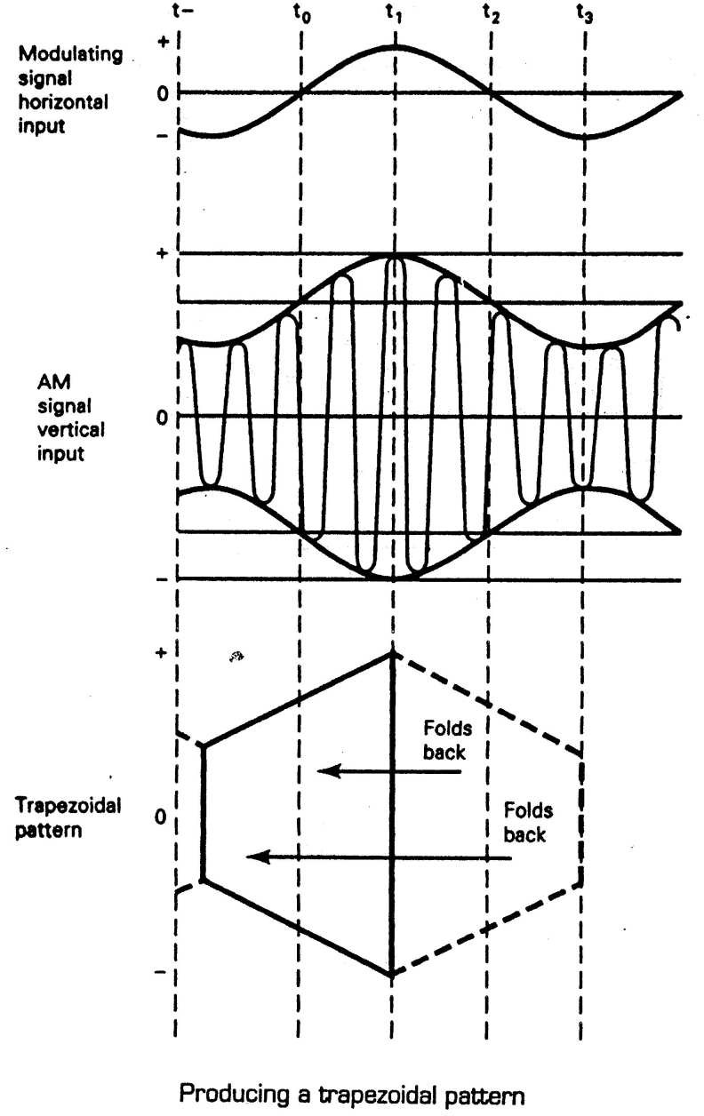

Fig.2 Producing Trapezoidal Waveform

Precautions:
- Connections should be made carefully.
- The resistors and capacitors must be identified properly before giving the circuit connections.
- The components must be properly doped into the bread board.

Results:

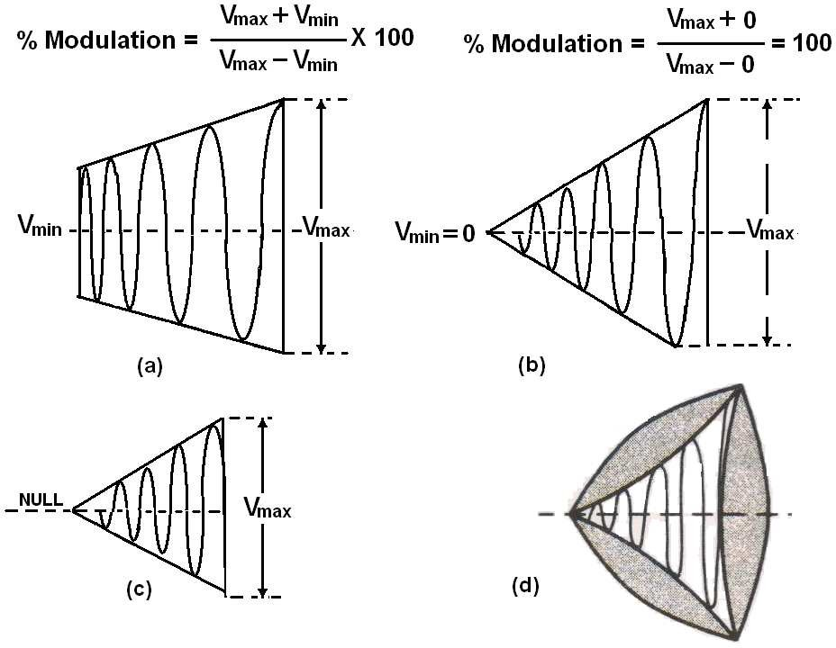
Fig.3. Trapezoidal patterns (a) Linear 50% AM modulation (b) 100% AM modulation (c) Over modulation (d) Improper relationships

Post-Lab Requirements

- Create the illustration for Mixer.
- Compare the results are obtained in hardware lab with that of computer simulations.
- Submit your illustration to the lab instructor at next week's lab.

Viva Questions:
- Why we need to modulation?
- What is Amplitude modulation index?
- If the X and Y rolls are interchanged what will happen? Can we measure the modulation index?
4.. What is the difference between DSB-FC and DSB-SC?

DSB-SC Modulation & Demodulation

Objectives:
- To construct and study the DSB-SC Modulation technique.
- To examine the time displays of an DSB-SC signal.
- To investigate the use (& limitation) of synchronous (envelope) detection for demodulating DSB-SC signals.

Pre-Lab Work:

- Basic theory of DSB-SC modulation using balanced modulator and synchronous detection techniques.
- Time and Frequency analysis of DSB-SC waves.
- Understanding the circuit diagrams of DSB-SC generation using balanced modulator and envelope detection.
- Understanding the data sheets of components used in the experiment.
- Computer simulations (Multisim / pSpice) are performed and the objectives are obtained prior to the hardware experiment.

Equipment and Components:

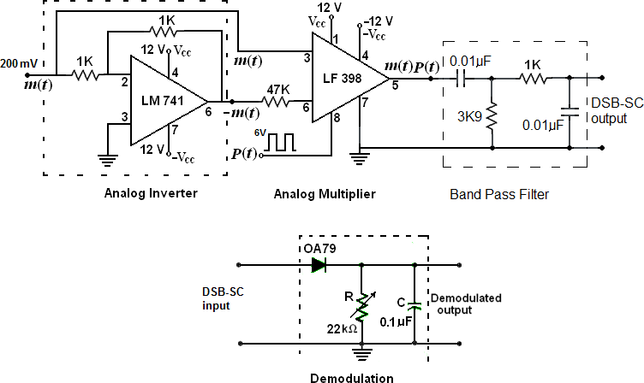
Circuit Diagram:
Fig 1. Circuit diagram of DSB-SC Modulation and Demodulation

Basic Theory: The block diagram of DSB-SC modulator is shown in Fig 2. A balanced modulator consists of two standard AM modulators arranged in a balanced configuration to suppress the carrier wave. We assume that the two modulators are identical except for the signal reversal of the modulating wave applied to the input of one of them. Thus the outputs of the two modulators are expressed as follows:

s1(t) = Ac[1+ kam(t)]cos 2π f_{c}t
and
s2 (t) = Ac[1− kam(t)]cos 2π f_{c}t

By subtracting
s2 (t) from
s1(t) , we obtain

s(t) = s1(t) − s2(t) =[2kam(t)Ac cos 2π f_{c}t]m(t) .

Hence except for the scaling factor 2ka
the balanced modulator output is equal to the

product of the modulating wave and carrier as required. An envelope detector is used for demodulation purpose.

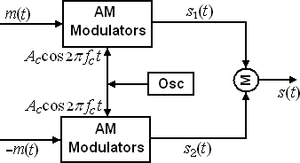

Fig. 2 Block diagram of Balanced Modulator
Procedure:

DSB-SC Modulation:
Analog Inverter:
- Initially wire the circuit for analog inverter circuit as shown in Fig.1.
- Set audio signal generator (modulating signal) to 1 kHz sine wave with 200 mV peak.
- Now observe the output wave form at the output of analog inverter (pin No6 of LM 741). This waveform should be inversion of the input sine wave.

Analog Multiplier:
- Now wire the analog multiplier circuit as shown in Fig.1.
- A square wave of 10 kHz with 6 Vpp is connected to the Pin. No.8 of LF 398.
- Observe the DSB-SC output at Pin No. 5 of LF 398.

- Now slightly increase and decrease the modulating signal and note how the DSB-SC modulation changes.

Demodulation:
- Now the demodulation circuit is connected across the output of DSB-SC modulator circuit.
- By varying the ‘ R ‘ observe the demodulated signal.
- By varying the modulating voltage in the DSB-SC modulation circuit, observe the demodulated signal.
- Similarly, by varying the modulating signal frequency in the modulation circuit, observe the demodulated signal.

Observations:
Model Wave Forms:
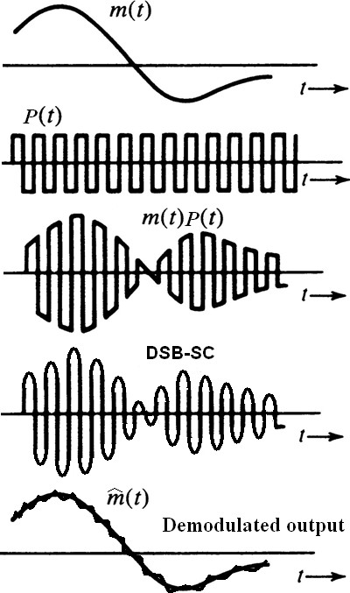

Fig 3. DSB-SC Modulation waveforms and Envelope detector output waveforms

Precautions:
- Check the connections before switching ON the power supply.
- The components must be properly doped into the bread board.
- Observations should be done carefully.

Results:

Post-Lab Requirements

- Create the illustration for Amplitude Modulation.
- Compare the results are obtained in hardware lab with that of computer simulations.
- Submit your illustration to the lab instructor at next week's lab.

Viva Questions:

- What are discrete frequencies in DSB-SC?
- What is the advantage of DSB-SC over AM?
- Mention the names of methods for DSB-SC generation?
- What do you mean by coherence detection and non-coherent detection?
- How a message signal recovered from DSBSC wave?
- What is the disadvantage of DSB-SC?
- What is the bandwidth of DSB-SC?
- Why DSB-SC is not used for commercial broad casting?
- Mention few applications for DSB-SC.

5. Characteristics of Phase Locked Loop

Objectives:
  - To build a LM 565 circuit to operate at any frequency with desired lock range and capture range.
  - Understanding the operation of the PLL LM565.

Pre-Lab work:
- Basic theory of Phased Locked Loop
- Understanding the circuit diagram of Phased Locked Loop.
- Understanding the data sheet of PLL LM 565.
- Computer simulations are performed and the objectives are obtained prior to the hardware experiments.

Equipment and Components:

Circuit Diagram:
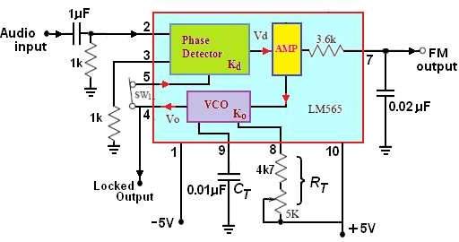
Fig. 1 LM565 PLL

Basic Theory:

A PLL is a closed loop feedback control system in which either the frequency or phase of the feedback signal is the parameter of interest rather than the magnitude of the signal’s voltage or current. The block diagram of PLL circuit is shown in Fig.2. As the figure shows, a PLL consists of four primary blocks: (1) a phase detector / comparator,

- a low-pass filer (LPF), (3) a low gain operational amplifier, and a voltage controlled oscillator (VCO) as shown in Fig.2.
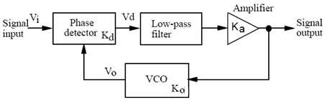
Fig. 2 PLL block diagram.

The phase detector within the PLL locks at its two inputs and develops an output that is zero if these two input frequencies are identical. If the two input frequencies are not identical, then the output of detector, when passed through the low-pass filter removing the ac components, is a dc level applied to the VCO input. This action closes the feed- back loop since the dc level applied to the VCO input changes the VCO output frequency in an attempt to make it exactly match the input frequency. If the VCO output frequency equals the input frequency, the PLL has achieved frequency locking, and the control voltage will be zero for as long as the PLL input frequency remains constant. The parameters of PLL shown in Fig.2 are as follows:
Kd = Phase detector gain in volts/radian
Ka = Amplifier gain in volt/volt
Ko = VCO gain in kHz/volt
KL = Kd Ka Ko = closed loop gain in kHz/volt
Once the frequency is locked, the phase detector of a PLL compares the phase of the input signal with that phase of the VCO and similar process is repeated until the phase is locked. If any frequency or phase changes occur in the input signal, the corresponding deviations will be detected by this PLL.

LM565 PLL Basic Characteristics:
The LM565 is a general-purpose phase-locked loop and is widely used in frequency demodulation. In designing with the LM565, the important parameters of interest are as follows:

Free-running Frequency:

Fig. 1 shows a PLL circuit with LM565. In the absence of the input signal, the output frequency of the VCO is called the free-running frequency f0 . In the PLL circuit of Fig. 1,

the free-running frequency of LM565 is determined by the timing components CT RT , and can be found by
and

Free running frequency
fo =
1

3.7 CT RT
(1)

Closed loop gain

Lock Range:
KL = Kd Ka Ko = 3.36 fo
Vc
(2)

Initially, the PLL is in already-locked state and the VCO is running at some frequency. If

the input frequency
fi is away from the VCO frequency f0 , locking may still occur.

When the input frequency reaches a specific frequency where the PLL loses lock, the

frequency difference of fi
LM565 can be found by
and
f0 is called the lock range of the loop. The lock range of

Capture Range:
fL = 8 fo
Vc

Initially, the loop is unlocked and the VCO is running at some frequency. If the input
frequency fi is close to the VCO frequency f0 , unlocking may maintain. When the input
frequency reaches a specific frequency where the PLL locks, the frequency difference of
fi and f0 is called the capture range of the loop. The capture range of LM565 can be

found by

f = 1 2π
2π fL
3.6X103CT
C

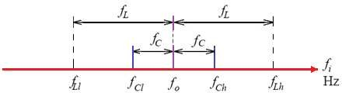
Fig.3 Illustration of lock and capture ranges.

Procedure:
- Connect the circuit diagram as shown in Fig. 1.
- Disconnect the Audio input signal.

- Adjust the RT
to obtain the maximum free-running frequency
f0h
and the

minimum free-running frequency a Table.
f0l at LM565 pin 4 (O/P). Record the results in

- Adjust the potentiometer RT
KHz.
to obtain the VCO free-running frequency
f0 = 5

- Connect a 0.5Vp-p, 5 KHz square wave to the input (I/P) terminal. Observe the PLL input (I/P) and the VCO output (pin 4) signals and slowly increase the input frequency until the output signal just unlocks. Record the input frequency as fLh in the Table.

- Return the input frequency to the free-running frequency
f0 of VCO. Slowly

decrease the input frequency until the output signal just unlocks and records the

input frequency as
fLl
in the Table 1.

- Using the equation
fL =
fLh − fLl, calculate the lock range.
2

- Increase the input frequency to force the VCO output unlocked. Slowly decrease

the input frequency until the PLL just locks. Observe the input frequency record the result in the Table.
fCh and

- Decrease the input frequency to force the VCO output unlocked. Slowly increase

the input frequency until the PLL just locks. Observe the input frequency record the result in Table.
fCl
and

- Using the equation fC =
fCh − fCl, calculate the capture range.

2

- Turn the potentiometer RT
to get the VCO free-running frequency
f0 of say

about 10kHz. Connect a 0.5Vp-p, square wave of the same frequency to the input (I/P). Repeat steps 6 to 10.

Observations:

Table

S.No  . | f0 | Free Running Frequency Range (Hz) | Lock Range  f L |  | Capture Range  fC
S.No  . | f0 | Free Running Frequency Range (Hz) | Theoretical | Practical | Theoretical | Practical
1 | 5 KHz | f0h =  f0l = | fLh = | fLh = | fCh = | fCh =
1 | 5 KHz | f0h =  f0l = | fLl = | f Ll = | fCl = | fCl =
1 | 5 KHz | f0h =  f0l = | fL = | fL = | fC = | fC =
2 | 10 KHz | f0h =  f0l = | fLh = | fLh = | fCh = | fCh =
2 | 10 KHz | f0h =  f0l = | fLl = | fLl = | fCl = | fCl =
2 | 10 KHz | f0h =  f0l = | fL = | fL = | fC = | fC =

Precautions:
- Connections should be made carefully.
- The components must be identified properly before giving the circuit connections.
- The components must be properly doped into the bread board.

Results:

Post-Lab Requirements:
- Create illustrations for characteristics of PLL LM 565.
- Compare the results are obtained in hardware lab with that of computer simulations.
- Submit your illustration to the lab instructor at next week’s lab.

Viva Questions:

- Examining the results of experiment, could you find that the VCO frequency would be when the input frequencies of LM565 were outside its lock range?
- Comparing the lock range with the capture range of LM565, which is the wider?
- What is gain constant of PLL?

6. Frequency Modulation and De-Modulation using PLL

Objectives:
- To construct and study the Frequency Modulation technique.
- To examine the time displays of an FM signal.
- To examine the frequency deviations for various modulating signal voltages.
- To measure the percentage of modulation, and total power in frequency modulation.
- To investigate the use FM demodulation using PLL.

Pre-Lab Work:
- Basic theory of Frequency Modulation techniques. Time and Frequency analysis of AM waves.
- Basic theory of PLL FM demodulation.
- Understanding the circuit diagrams of FM generation and detection.
- Understanding the data sheets of components used in the experiment.
- Computer simulations (Multisim / pSpice) are performed and the objectives are obtained prior to the hardware experiment.
Equipment and Components:

  - Signal generator
  - CRO

3. IC XR-2206, LM 565
- Resistors

Capacitors.
- Connecting wires &probes

Basic Theory:
Modulation is concerned with changing some characteristics of a high frequency carrier wave in accordance with the amplitude of the modulating signal to be transmitted. Frequency modulation is a system in which the frequency of the carrier is varied in accordance with the amplitude variations of the message signal; whereas the amplitude of the carrier remains unaltered. In FM the information is being carried by the carrier in its frequency variations and not in amplitude. This is a great advantage in FM because the noise generally affects the amplitudes of the waveform.
The mathematical representation of FM is given by

s (t) = A
cos ⎡ω
t + 2πk
t m(α ) dα ⎤

FM c
⎣⎢ c
f ∫−∞ ⎥⎦

where c(t) = Ac cosωct
is RF carrier signal,
m(t) is modulating signal and k f is

frequency modulation sensitivity constant. For a single-tone modulating signal, the FM wave is represented by
⎣ ⎦

s_{FM} (t)
= Ac cos ⎡ωct + β f sin 2π fmt ⎤

where β
= k f Am = Δf

is called frequency modulation index, and where again

f fm fm
Δf = k f Am is known as frequency deviation. The bandwidth required to propagate

an FM wave according to the Carson’s rule is represented by B.WFM
Hz. The circuit diagram of Frequency Modulation is shown in Fig.1.

Frequency Demodulation:
= 2(Δf + k f )

Frequency demodulation is the process that enables one to extract the original modulating from the frequency modulated wave. This can be achieved by a system which has a transfer characteristics just inverse of voltage controlled oscillator (VCO). In other words a frequency demodulator produces an output voltage whose instantaneous frequency of input FM signal. There are various kinds of FM demodulation techniques are available. In this experiment PLL based Frequency demodulation technique is used and the circuit is shown in Fig 2.

Circuit Diagram:
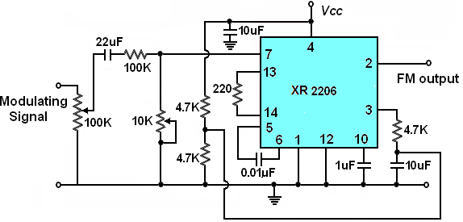

Fig.1 Circuit diagram of Frequency Modulation

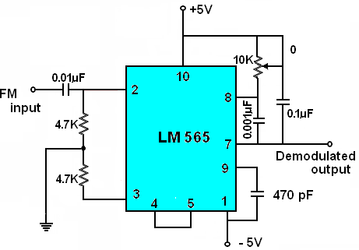
Fig.2 Circuit diagram of FM Demodulation

Procedure:
Frequency Modulation.
- Connect the Frequency Modulation circuit diagram shown in Fig.1.
- Measure the frequency of the carrier signal at the FM output terminal with the modulating signal is zero and plot the same on graph.
- Apply the modulating signal of 500HZ with 1Vp-p.
- Observe the modulated wave on the C.R.O & plot the same on graph.
- Find the modulation index by measuring minimum and maximum frequency deviations from the carrier frequency using CRO.
- Determine the bandwidth of FM wave
- Repeat the steps 5 and 6 by changing the amplitude and /or frequency of the modulating Signal.

FM Demodulation:
- Now wire the circuit as per the FM demodulation circuit shown in Fig.2.
- Initially lock the VCO of PLL to the carrier frequency of FM wave.
- Now apply the modulated signal as an input to demodulator circuit and compare the demodulated signal with the input modulating signal & also draw the same on the graph.
- Observe the demodulated output for changing the amplitude and /or frequency of the modulating Signal.

Observations:

S.No | Am  Volts | fc  Hz | fm  Hz | fmax  Hz | fmin  Hz | Freq. Deviation  Δf | Modulation index
1
2

Model Wave Forms:
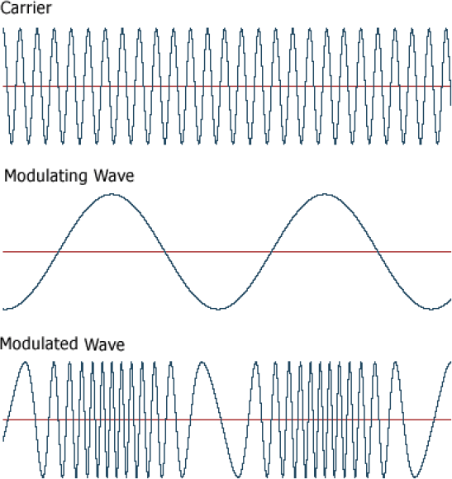

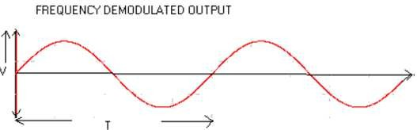

Precautions:

- Connections should be made carefully.
- The components must be identified properly before giving the circuit connections.
- The components must be properly doped into the bread board.

Results:

Post-Lab Requirements

- Create the illustration for Frequency Modulation.
- Compare the results are obtained in hardware lab with that of computer simulations.
- Submit your illustration to the lab instructor at next week's lab.

Viva Questions:

- Define frequency modulation?
- Mention the advantages of indirect method of FM generation?
- Define modulation index and frequency deviation of FM?
- What are the advantages of FM?
- What is narrow band FM?
- Compare narrow band FM and wide band FM?
- Differentiate FM and AM?
- How FM wave can be converted into PM wave?
- State the principle of reactance tube modulator?
- Draw the circuit of varactor diode modulator?
- What is the bandwidth of FM system?
- Want is the function of FM discriminator?
- How does ratio detector differ from fosterseely discriminator?
- What is meant by linear detector?
- What are the drawbacks of slope detector?

7. Pre-Emphasis and De-Emphasis

Objectives:
- To observe the characteristics of pre-emphasis at the transmitter,

- To observe the characteristics of de-emphasis circuit at the receiver.

- To draw frequency curves of pre-emphasis and de-emphasis.

Pre-lab work:
- Basic theory of noise and its frequency spectrum.
- Basic theory FM system and noise effect with modulating signal frequencies.
- Understanding the pre-emphasis and de-emphasis circuits
- Understanding the data sheets of components used in the experiment.
- Computer simulations (Multisim / pSpice) are performed and the objectives are obtained prior to the hardware experiment.

Equipment and Components:

Basic Theory:
Frequency modulation is more immune to noise than AM and is significantly more immune to noise than PM. Natural tendency of audio is that the amplitude of the high frequency signal is lower as compared to the amplitude of lower frequency signal.
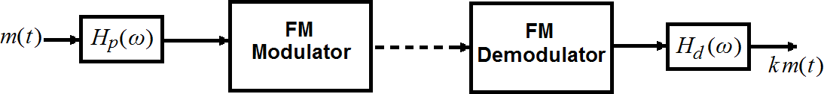
Pre-emphasis and De-emphasis are compensation circuits used to improve the SNR of FM system. The noise has more effect on the higher modulating frequencies than on the lower modulating frequencies. Thus, if the higher frequencies were artificially boosted at the transmitter and correspondingly attenuated at the receiver, an improvement in noise immunity could be expected, thereby increasing the SNR ratio. This boosting of the higher modulating frequencies at the transmitter is known as pre-emphasis and the compensation at the receiver is called de-emphasis.

Fig.1 Pre-emphasis and De-emphasis in an FM system.

Pre-emphasis: The circuit diagram of pre-emphasis is shown in Fig 2(a), used before modulation takes place to boost the high frequency modulating signals. The signal received has an increased level of the higher frequencies being applied to the modulator results in a better transmitted audio signal to noise ratio due to the high frequency components being above the noise as much or more than the low frequency components. Pre-emphasis is needed in FM to maintain good signal to noise ratio.

Circuit diagram of Pre-emphasis: R₁ = 7.5 KΩ R₂ = 1KΩ and C = 10nF

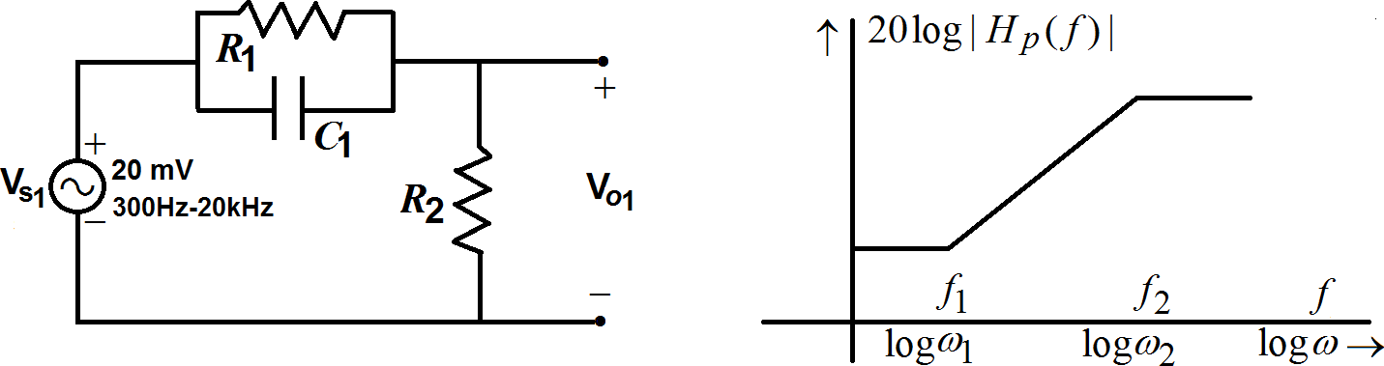
Fig 2 Pre-emphasis filter and its frequency response

The transfer function of Pre-emphasis circuit is given by

H p (ω) = K
jω+ω1 = K 1+ j( f / f1)

where K is gain,
jω+ω2
f1 = 1 = 1

and
1+ j( f / f2 )
f2 = 1 = R₁ + R₂

2πτ₁ 2π R₁C
2πτ ₂ 2π R₁R₂C

Procedure:

- Connect the circuit as per circuit diagram as shown in Fig.2.
- Apply the sinusoidal signal of amplitude 20mV as input signal to pre emphasis circuit.
- Then by increasing the input signal frequency from 300Hz to 20KHz, observe the
output voltage (V ) and calculate gain 20 log⎛ Vo1 ⎞ .
⎝ ⎠

o1

- Plot the graph between gain Vs frequency.
⎜ Vs1 ⎟

Sample Readings:
Vs1 = 20mV

Table: 1:

S.No | Frequency (kHz) | Vo1 mV | ⎛ V ⎞  Gain 20 log⎜ o1 ⎟  ⎝ Vs1 ⎠

De-emphasis: In order to reduce the effect of noise the high frequency signals are boosted before the transmission is known as pre-emphasis. When these signals are recovered at the receiver in order to restore the original amplitudes of high frequency signals are suppressed at the transmission.. This process is known as de-emphasis. This de-emphasis circuit is placed at the receiving side and acts as a low pass filter.

Circuit diagram of De-emphasis: R₃ = 6.8 KΩ and C₂ = 0.1uF
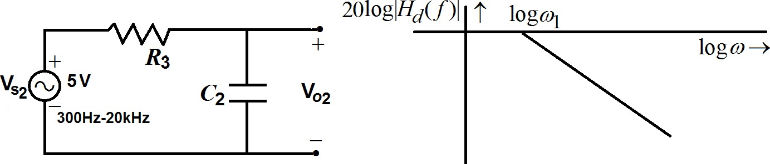
Fig 3 De-emphasis filter and its frequency response

Procedure:
- Connect the circuit as per circuit diagram as shown in Fig.3.
- Apply the sinusoidal signal of amplitude 5V as input signal to pre emphasis circuit.
- Then by increasing the input signal frequency from 300Hz to 20KHz, observe the
output voltage (V ) and calculate gain 20 log⎛ Vo2 ⎞ .
⎝ ⎠

o2

- Plot the graph between gain Vs frequency.
⎜ Vs2 ⎟

Sample Readings:
Vs2 = 5V

Table: 2:

S.No | Frequency (kHz) | Vo2 V | ⎛ V ⎞  Gain 20 log⎜ o2 ⎟  ⎝ Vs2 ⎠

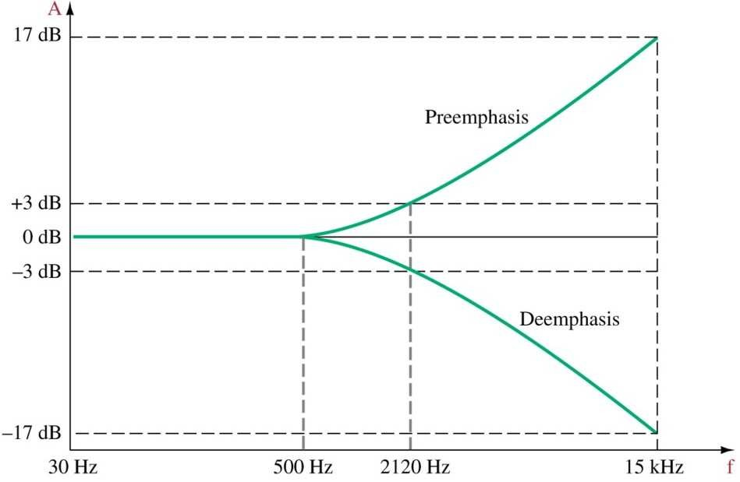
Model graph:

Precautions:
  - Connections should be made carefully.
  - The components must be identified properly before giving the circuit connections.
  - The components must be properly doped into the bread board.

Results:

Post-Lab Requirements

- Create the illustration for Mixer.
- Compare the results are obtained in hardware lab with that of computer simulations.
- Submit your illustration to the lab instructor at next week's lab.

Viva Questions:

- Which range of frequencies is more prone to noise interference?
- Why pre-emphasis and de-emphasis circuits are not used in AM systems?
- What is the need for pre-emphasis?
- Explain the operation of pre-emphasis circuit?
- Pre-emphasis operation is similar to high pass filter explain how?
- If de-emphasis circuit is not used in FM receiver, what is the demodulated output?
- De-emphasis operation is similar to low pass filter justify?
- Draw the frequency response of a pre-emphasis circuit?
- Draw the frequency response of a de-emphasis circuit?
- Give the formula for the cutoff frequency of the pre-emphasis circuit?
- What is the significance of the 3db down frequency?
- Where the pre-emphasis circuit is used ?
- Where the de-emphasis circuit is used ?

8. Pulse Amplitude Modulation and Demodulation

Objectives:
- To construct and study the Pulse Amplitude Modulation technique.
- To examine the time displays of PAM signal.
- To study the effect of PAM for varying width of carrier pulse train.
- To study the demodulating PAM signals.

Pre-Lab Work:
- Basic theory of Pulse Amplitude modulation techniques. Time and Frequency analysis of PAM waves.
- Basic theory of PAM demodulation techniques.
- Understanding the data sheets of components used in the experiment.
- Computer simulations (Multisim / pSpice) are performed and the objectives are obtained prior to the hardware experiment.

Equipment and Components:

Circuit Diagram:

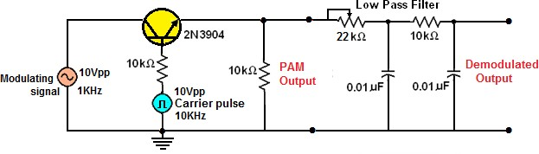

Brief Theory:
Fig.1 Circuit diagram of PAM modulation and demodulation.

PAM Modulation:
Pulse modulation is one form of pulse modulation used in the transmission of digital signals in a message processing format. In PAM, the RF carrier pulses amplitude is varied in accordance with the instantaneous values of a continuous message signal. The simplest form of the PAM modulator is an analog switch that is turned on and off at the RF carrier pulse rate. As the switch changes state, the intelligence signal is connected and disconnected from the output. Thus the output PAM signal is a sampled version of the input intelligence signal. The PAM wave contains upper and lower side band

frequencies besides the modulating and pulse signals. Fig.1 shows the circuit diagram of PAM modulation.

PAM Demodulation:
A spectral analysis of complex PAM signal reveals that the intelligence signal frequency components are far removed in frequency from the other frequency components of the complex PAM waveform. This is true only if the sampling rate is considerably higher than the highest intelligence frequency being used. Thus if the sampling rate is kept enough in comparison to the intelligence signals being used, a simple low pass filter (LPF) can be used as a PAM demodulator to retrieve the original information.
In the PAM demodulated process, the PAM signal is passed through a low pass filter having a cut-off frequencies equal to the highest frequency in the modulating signal. At the output of the filter, the modulating signal along with the DC component is available. PAM has the same signal to noise ratio as AM and so it is not employed in practical circuits. Fig.1 shows the circuit diagram of PAM demodulation.

Procedure:

- Connections are made as per the PAM circuit diagram shown in Fig.1.
- Set the modulating frequency to 1 KHz, magnitude 10Vp-p.
- Set the pulse carrier (sampling) frequency to 10 KHz, 10Vp-p and 50 % duty cycle.
- Observe the PAM wave output on CRO.
- Measure the levels of Vmax and Vmin .
- Observe the demodulated output. If necessary set the potentiometer to a value such that the demodulated output is reproduced without any distortion.
- Now increase the frequency of the input sinusoidal (the amplitude the same) to 300 Hz, 1200 Hz (the Nyquist frequency) and 1800 Hz. Comment on the PAM modulated waveforms.
- Now vary the magnitude of the input sinusoidal signal (the frequency is remains constant).
- Observe the PAM output and corresponding demodulated output in each case.

Model Wave Forms:
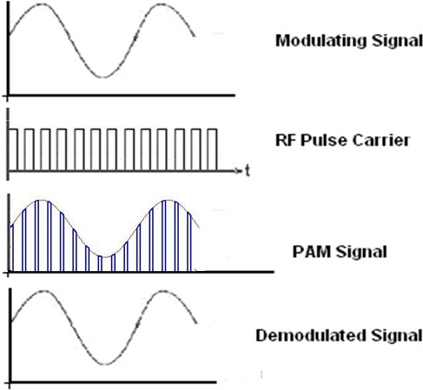

Precautions:
Fig 2. Pulse Amplitude Modulation and Demodulation

- Connections should be made carefully.
- The components (resistors, capacitors and ICs ) must be identified properly before giving the circuit connections.
- The components must be properly doped into the bread board.

Results:

Post-Lab Requirements

- Create the illustration for Pulse Amplitude Modulation.
- Compare the results are obtained in hardware lab with that of computer simulations.
- Submit your illustration to the lab instructor at next week's lab.

Viva Questions:

- What are the classifications of pulse modulation techniques?
- What is the transmission bandwidth of Pulse amplitude modulation?
- What are the limitations in Pulse amplitude modulated signal?
- What do you mean by synchronization in PAM?
- Write the standard equation of a PAM in frequency domain?
- What is meant by Aperture effect?
- Draw the frequency spectrum of a PAM signal?
- What is the time domain representation of a PAM signal?
- What are the major differences between PAM &PWM?
- Which type of sampling technique is used in PAM signal?

9. Pulse Width Modulation and Demodulation

Objectives:
- To construct and study the Pulse Width Modulation technique.
- To examine the time displays of PWM signal.
- To study the demodulating PWM signals.

Pre-Lab Work:
- Basic theory of Pulse Width modulation techniques. Time and Frequency analysis of PAM waves.
- Basic theory of PWM demodulation techniques.
- Understanding the data sheets of components used in the experiment.
- Computer simulations (Multisim / pSpice) are performed and the objectives are obtained prior to the hardware experiment.

Equipment and Components:

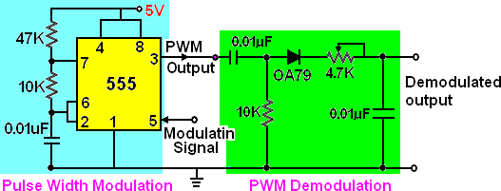
Circuit Diagram:

Basic Theory
Fig.1 Pulse width Modulation and Demodulation

Pulse Time Modulation is also known as Pulse Width Modulation or Pulse Length Modulation. In PWM, the samples of the message signal are used to vary the duration of the individual pulses. Width may be varied by varying the time of occurrence of leading edge, the trailing edge or both edges of the pulse in accordance with modulating wave. It is also called Pulse Duration Modulation. In Pulse width modulation, the amplitude of the pulses is constant. In generation of PWM, the input modulating signal is applied to non - inverting terminal of op-amp. The op-amp now compares this modulating signal with internally generated saw tooth signal. The output of the comparator is high only when

instantaneous value of input modulating signal is grater then that of saw tooth waveform. When saw tooth waveform voltage is grater then input modulating signal at that instant the output of the comparator remains zero i.e. in negative saturation. Thus output of comparator is PWM signal. A low pass filter is used to demodulate the PWM modulated signal as shown in Fig.1.

Procedure:

- Connections are made as per the PWM circuit diagram shown in Fig.1.
- Set the modulating frequency to 200HZ, magnitude 2Vp-p.
- Observe the PWM wave output on CRO.
- Now wire the demodulation circuit as shown in Fig.1.
- Observe the demodulated output. If necessary set the potentiometer to a value such that the demodulated output is reproduced without any distortion.
- Now vary the magnitude of the input sinusoidal signal (the frequency is remains constant).
- Observe the PWM output and corresponding demodulated output in each case.
- Now increase the frequency of the input sinusoidal (the amplitude and offset remains the same) to 400 Hz, 500 Hz and 600 Hz. Comment on the PWM modulated waveforms.
- Observe demodulation output for increase the frequency of the input sinusoid as in step 6.

Output Waveform:
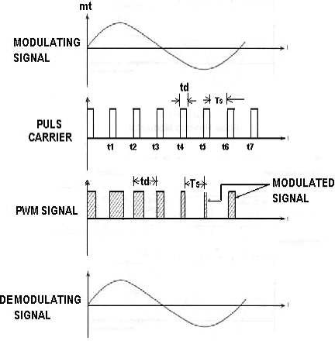

Fig.2. Expected waveforms

Precautions:
- Connections should be made carefully.
- The components (resistors, capacitors and ICs ) must be identified properly before giving the circuit connections.
- The components must be properly doped into the bread board.

Results:

Post-Lab Requirements

- Create the illustration for Pulse Width Modulation
- Compare the results are obtained in hardware lab with that of computer simulations.
- Submit your illustration to the lab instructor at next week's lab.

Viva Questions:

  - What are the different types of PTM systems?
  - What is the other name of Pulse width modulation?
  - What do you mean by pulse time modulation?
  - What is the comparison between the PAM and PWM?
  - What is the definition of PWM?
  - What is the transmission bandwidth of PWM signal?
  - Which type sampling technique is used in PWM?
  - What are the applications of PWM modulation technique?

10. Pulse Position Modulation

Objectives:
- To construct and study the Pulse Position Modulation technique.
- To examine the time displays of PPM signal.
- To study the demodulating PPM signals.

Pre-Lab Work:
- Basic theory of Pulse Position modulation techniques. Time and Frequency analysis of PPM waves.
- Basic theory of PPM demodulation techniques.
- Understanding the data sheets of components used in the experiment.
- Computer simulations (Multisim / pSpice) are performed and the objectives are obtained prior to the hardware experiment.

Equipment and Components:

Circuit Diagram:
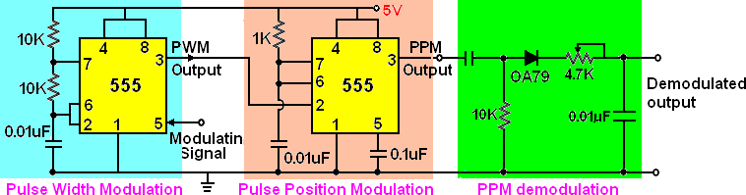
Fig1. The circuit diagram of Pulse Position Modulation using PWM and Demodulation.

Basic Theory:
In Pulse Position Modulation, both the pulse amplitude and pulse duration are held constant but the position of the pulse is varied in proportional to the sampled values of the message signal. Pulse time modulation is a class of signaling techniques that encodes the sample values of an analog signal on to the time axis of a digital signal and it is analogous to angle modulation techniques. The two main types of PTM are PWM and PPM. In PPM the analog sample value determines the position of a narrow pulse relative to the clocking time. In PPM rise time of pulse decides the channel bandwidth. It has low noise interference. Generation of PPM is carried out by giving the pulse width

modulated output to mono-stable multi-vibrator as shown in Fig.1. A low pass filter is used to demodulate the PWM modulated signal as shown in Fig.1.
Output Waveform:
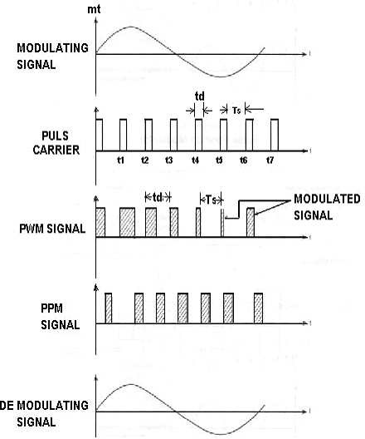

Precautions:

- Connections should be made carefully.
- The components (resistors, capacitors and ICs ) must be identified properly before giving the circuit connections.
- The components must be properly doped into the bread board.

Results:

Post-Lab Requirements

- Create the illustration for Pulse Width Modulation
- Compare the results are obtained in hardware lab with that of computer simulations.
- Submit your illustration to the lab instructor at next week's lab.

Viva Questions:

- Define PPM?
- What are the differences between PPM & PWM?
- Which type of sampling technique is used in PPM?
- The Multivibrator used in PPM is ?
- Pulse duration of PPM is ?
- In PPM the position is proportionally varied in which parameter of the modulating signal?

